GAME DAY FIELD PREPARATION
FIELDS@EHYLLL.COM TEXT 714-813-0277
There is a small bin at each field (in the dugout or behind home plate) that should contain the following:
- Hose with coupler and nozzle.
- Marking spray paint
- Marking paint cart
- String line
- Base peg dig tool
- Bases
Each field should also have:
- Batter’s box template
- Landscape rake
IF ANY OF THE ABOVE ITEMS ARE MISSING OR BROKEN, OR IF THERE ARE ANY OTHER FIELD ISSUES, PLEASE LET US KNOW VIA EMAIL OR TEXT.
Steps to prepare a field on game day:
- Use the landscape rake to fill any low spots (batter’s box, pitcher’s mound, around the bases).
- Water the infield lightly.
- Drag the field using the Gator and drag mat from the sea container.
- Install the bases.
- Use the bater’s box template to mark the outline of the batter’s box.
- Use the spray paint and paint cart to create the batter’s box. If necessary, lightly water the batter’s box again. The paint sticks better to damp dirt.
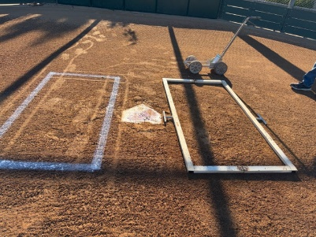
- Run the string line from the rear point of home plate along the outside edge of first base to the outside edge of the outfield foul line. If necessary, lightly water the foul line again.
- Use the spray paint and paint cart to create the first base foul line on the inside of the string line.
- Repeat for the third base foul line.
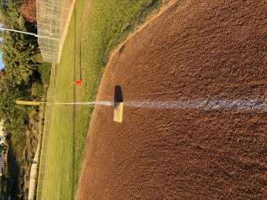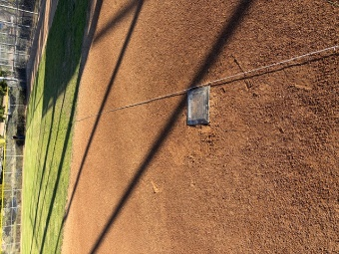

Additional info:
- The width of the paint line can be adjusted by turning the nozzle on the paint can.
- Home plate, the foul line and the bases are in fair territory. The picture depicts how the foul line should intersect first and third base.
- The dugout templates have a mark indicating which end of the template should face the field.
- If you have time, it is most effective to drag the field in small circles. There is also a 6’ wide brush drag the can be used in addition to the drag mat.
- If you are the last game or practice of the day:
- Return the bases to the bin.
- Insert the base plugs into the base pegs.
- Water the field lightly and drag the field.
- The centerfield gate at the Mustang Majors field should be kept locked open except for games and practices.

